EE6350: Class-D Audio Amplifier Report

Hang Guan (hg2388)
Alexander Gazman (ag3529)

Nov 5, 2015

This report discusses a single-channel, efficient, class-D audio power amplifier for driving stereo speakers in a half-bridge configuration. It is designed to drive 8-ohm speaker with a gain of four. The chip can accept an analog signal as an audio input. In our case, we connected the audio input to the output of the radio.

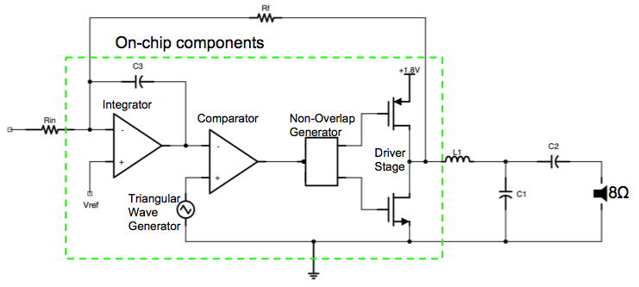
Fig. 1: Top-level schematic of the class-D amplifier

This report is organized as following: section 1 covers the transistor level design of all the building blocks; section 2 shows the simulation results of some building blocks and the whole amplifier; section 3 discusses the layout of each block; section 4 is the PCB design; section 5 shows the test results; section 6 and 7 are conclusions and references.

1 Transistor-level design
  - Output Transconductance Amplifier (OTA)
Here, we adopted a two-stage Miller OTA, as shown in Fig. 2. The OTA has a simulated DC gain of 70 dB and phase margin larger than 60 degree. It uses an 20 uA biasing current with a power dissipation less than 300 uW.

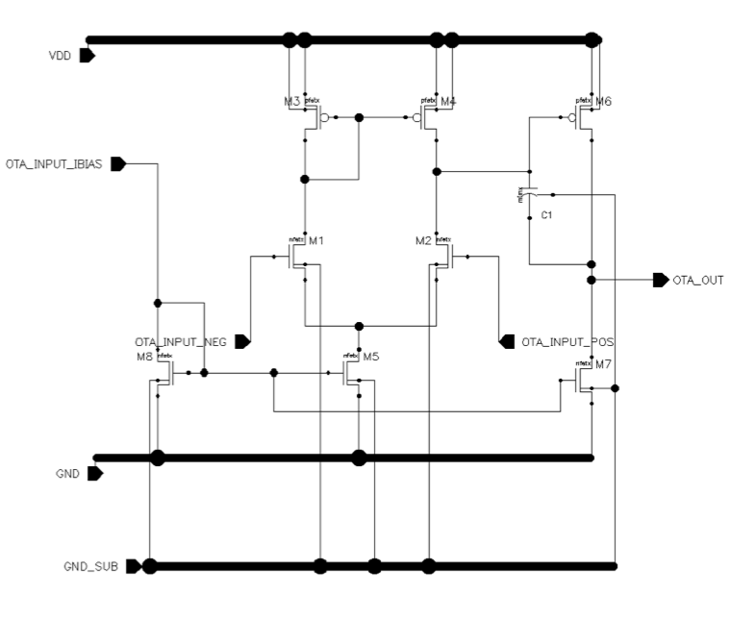
Fig. 2: Schematic of the 2-stage OTA (bias circuit not shown)

  - Comparator
We used a two-stage differential-input single-ended output OpAmp for our comparator, as shown in Fig. 3.
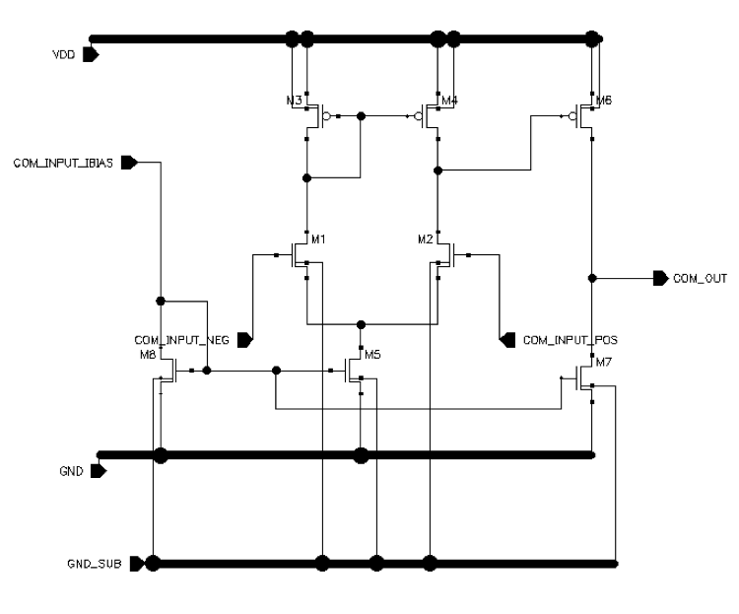.
Fig. 3: Schematic of the 2-stage comparator (bias circuit not shown)

  - Triangle wave generator
We adopted a triangle wave generator, using an integrator driving a comparator that is connected as a Schmitt trigger, as shown in Fig. 4. The detailed discussion is given in the literature [1]. To get a 500 KHz triangle wave, we choose R6 = 100 K ohm, R7 = 6 K ohm, R8 = 15 K ohm, and C4 = 10pF.
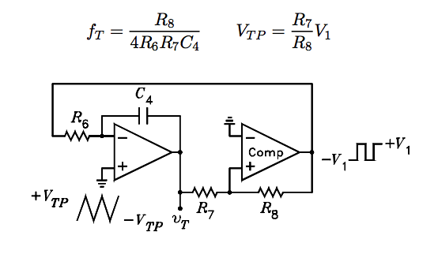
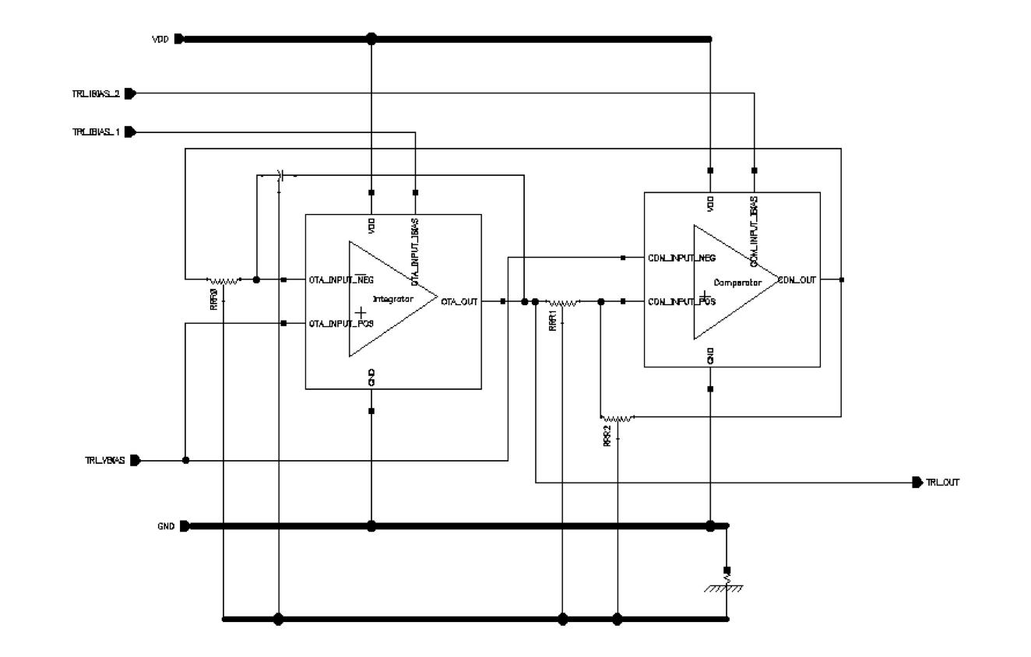
Fig. 4: Schematic of the triangle wave generator

  - Non-overlap generator
The non-overlap generator comprises two NAND gates, one NOT gate, two capacitors and two buffer chains. The digital gates are all standard CMOS structures with 1.8 um / 0.2 um for NMOS and 7.2 um / 0.2 um for PMOS. C = 10 pF is a MIM-capacitor that is responsible or providing the 20ns non-overlap period that we need. Since the waveform at the output of the NAND gate is very slow, we use buffers to improve the slew rate of this waveform. The implementation is shown in Fig. 5.
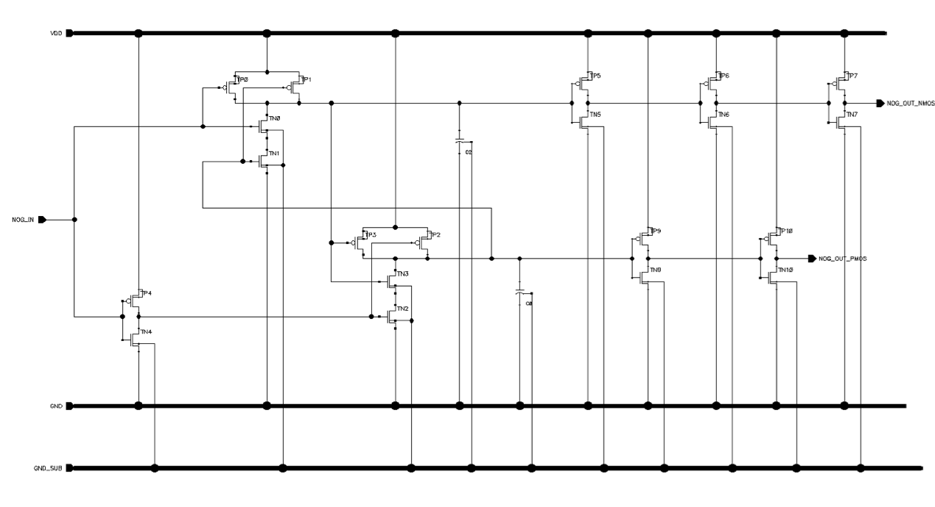
Fig. 5: Schematic of the triangle wave generator
  - Bias circuit
We used the cascaded PMOS current mirror, which can copy the reference current with a better accuracy. The transistors are all sized to 48 um / 1 um. The bias circuit is shown in Fig. 6.
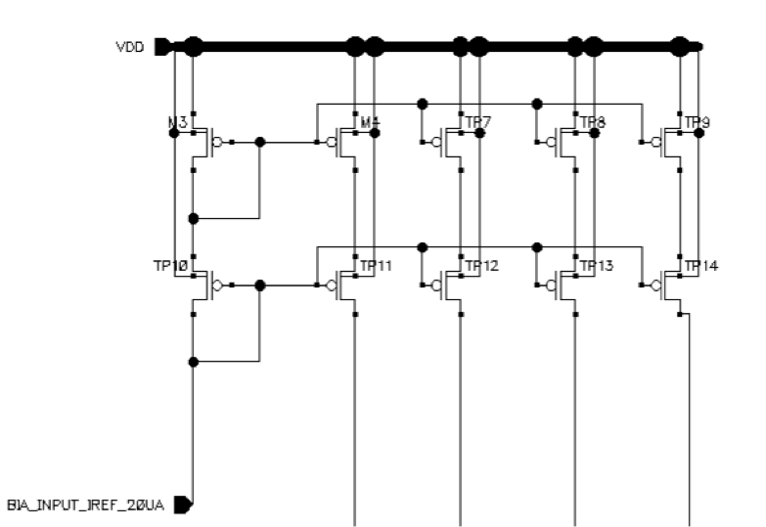
Fig. 6: Schematic of the bias circuit

  - Output driver
The output driver is a simple inverter. The primary consideration while determining the size of these transistors is the desired power efficiency. In other words, we need to minimize the on resistance of both NMOS and PMOS transistor such that most of the voltage is dropped by the load resistor. In our design, we choose a PMOS with a size of 60 mm / 1 um and NMOS with a size of 20 mm / 1 um. The output driver is shown in Fig. 7.
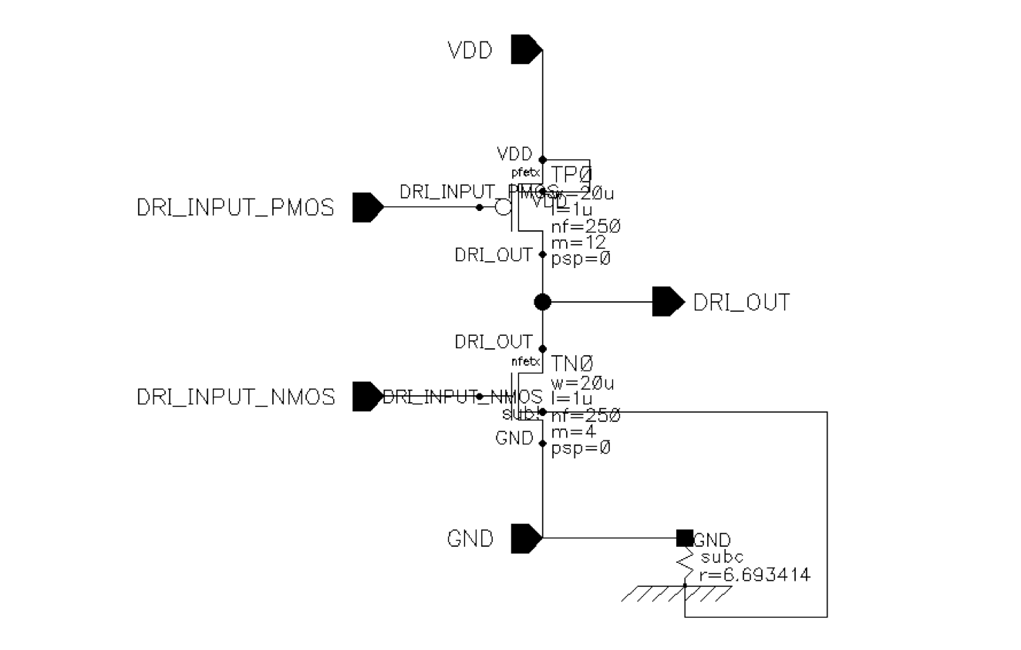
Fig. 7: Schematic of the output drive

- Simulation results
We did PVT (Process, Voltage, Temperature) simulations for all the building blocks. There are totally 45 different combinations: corner_list = {ff, tt, ss, fs, sf} VDD_list = {1.6, 1.8, 2.0}, and temperate_list = {-25, 27, 80}.
  - Comparator
The comparator has a DC gain of 70 dB, unity-gain bandwidth of ~ 50 MHz, and phase margin larger than 60 degree.

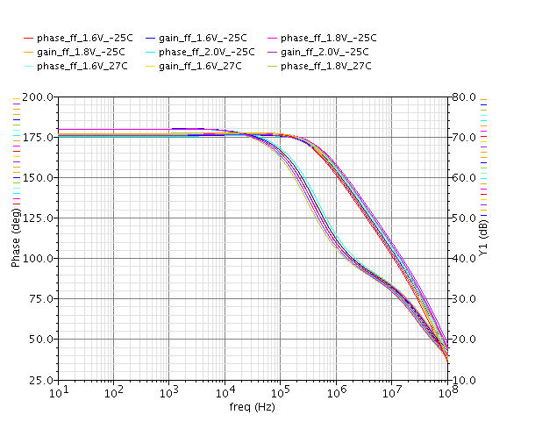
Fig. 8: Comparator simulation result
  - Non-overlap generator
The non-overlap time is within the range from 15 ns to 23 ns, as shown in Fig. 9.
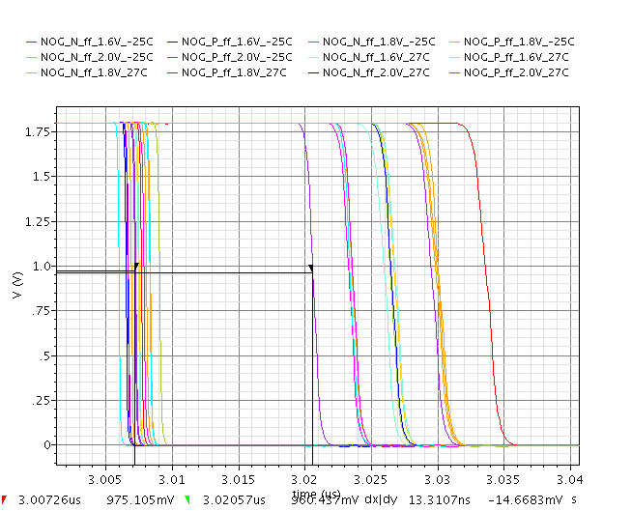
Fig. 9: Non-overlap generator simulation result

  - Input and output waveforms
Fig. 10 shows the simulation results of the input and output signals. The input signal is a 5 KHz sine wave with a DC biasing voltage of 0.9 V and a Vpp of 400 mV. The output voltage is taken from the 8 ohm load resistor.
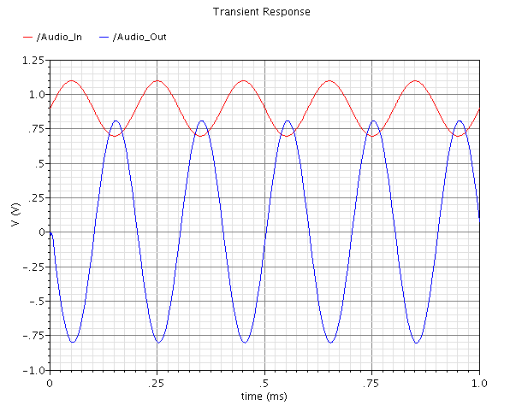
Fig. 10: input and output simulation result
  - PWM and triangle waveforms
Fig. 11 shows the internally generated triangle wave out from the triangle wave generator and the PWM signal out from the comparator.
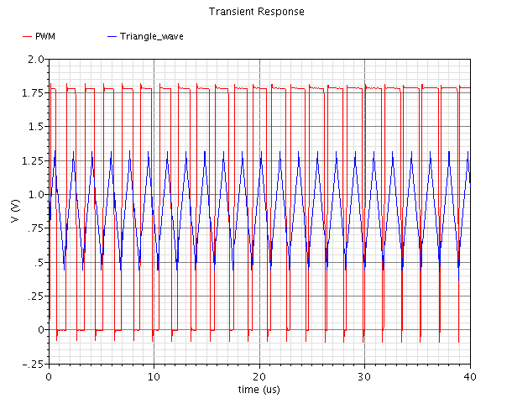
Fig. 11: input and output simulation result

- Layout
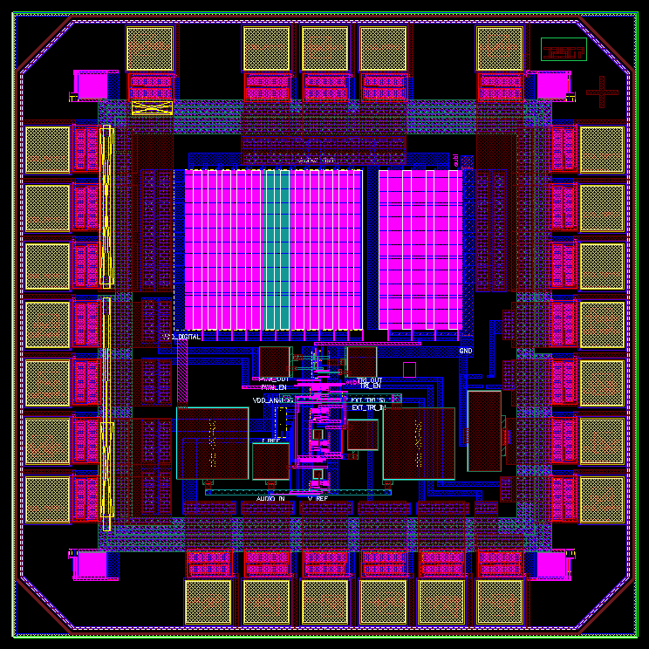
Fig. 12: Layout of the chip in Virtuoso

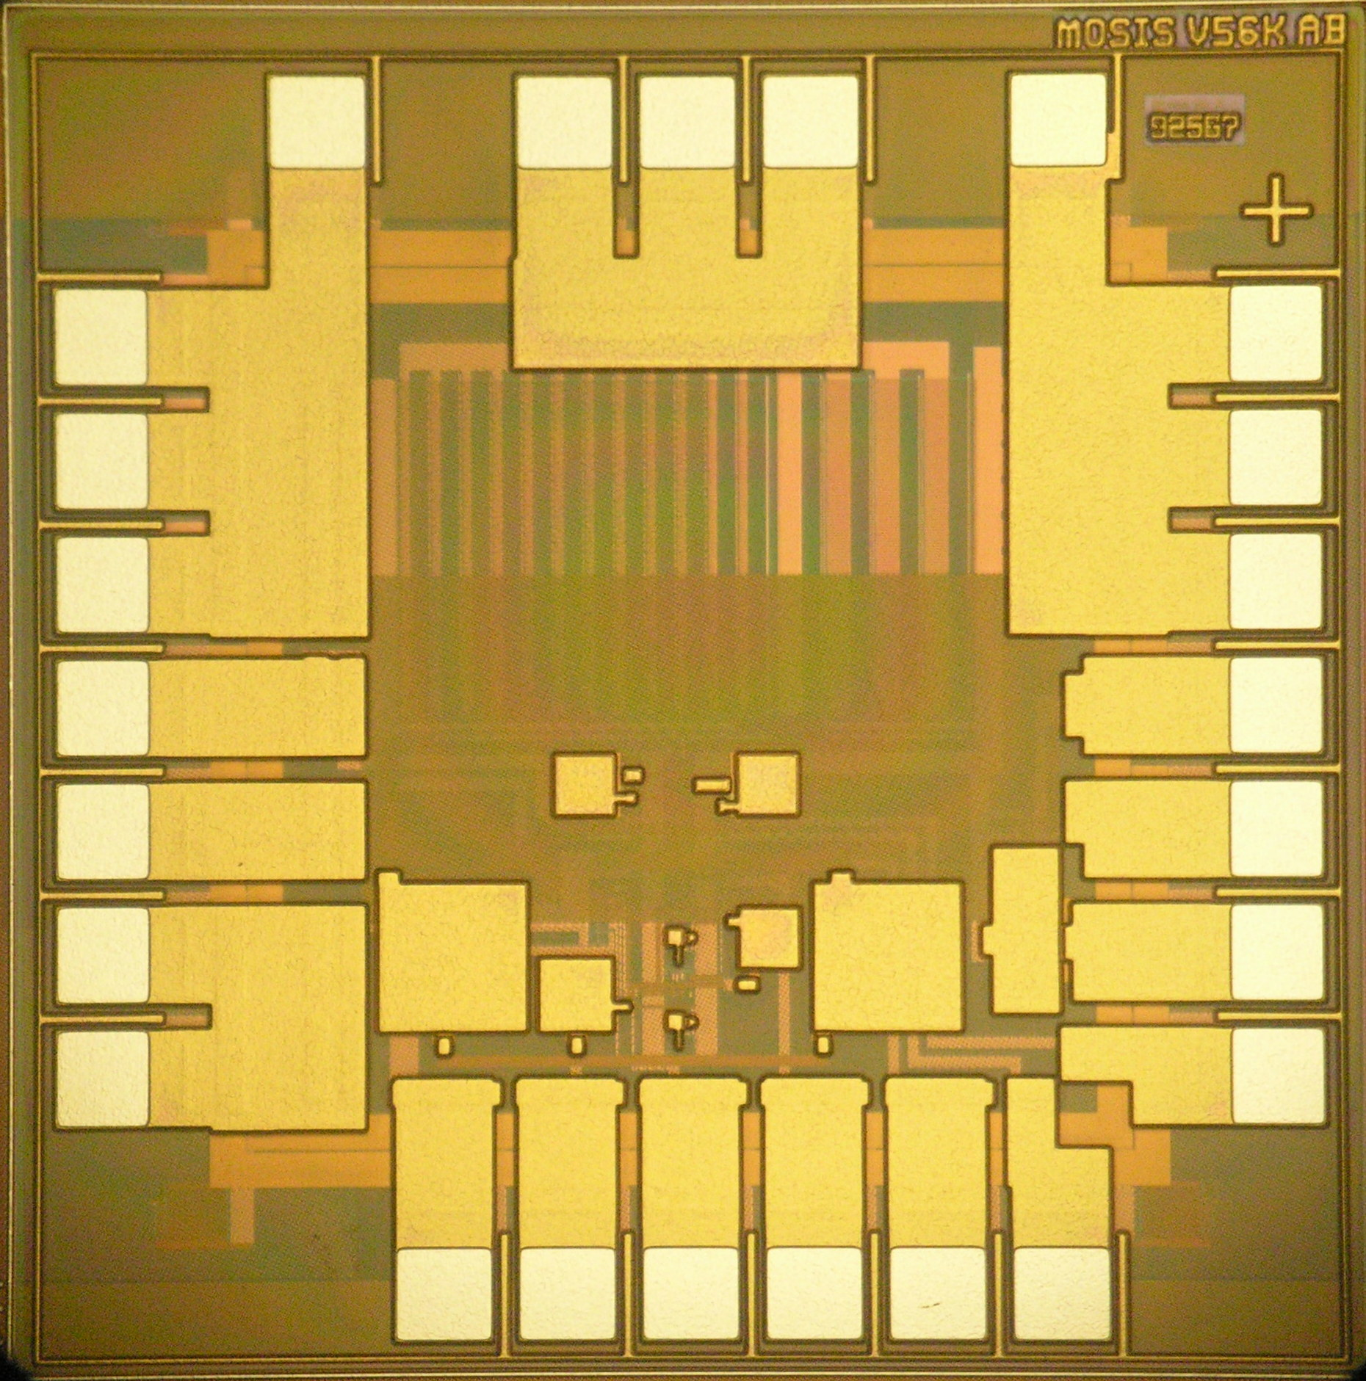
Fig. 13: Chip photo after fabrication

This amplifier was layout using IBM 180-nm RF CMOS process. It was fabricated in MOSIS foundry and packaged using MOSIS DIP28 package. The layout size is 1500 x 1500 microns. Top-level layout is seen in Fig. 12. The signal enters from the bottom side of the layout and exits from the top. A "+" marker at the top-right is used to indicate the orientation with respect to the package. The chip photo after fabrication is shown in Fig. 13.

  - Output Transconductance Amplifier (OTA)
The layout of OTA is seen in Fig. 14. The transistors in the layout were arranged in roughly the same manner as the transistors in the schematic. The input signals of the OTA enter from the left and the output is taken from the right. Supply and ground buses run horizontally along the top and the bottom of the layout. The Miller capacitor was realized using a MIM capacitor.
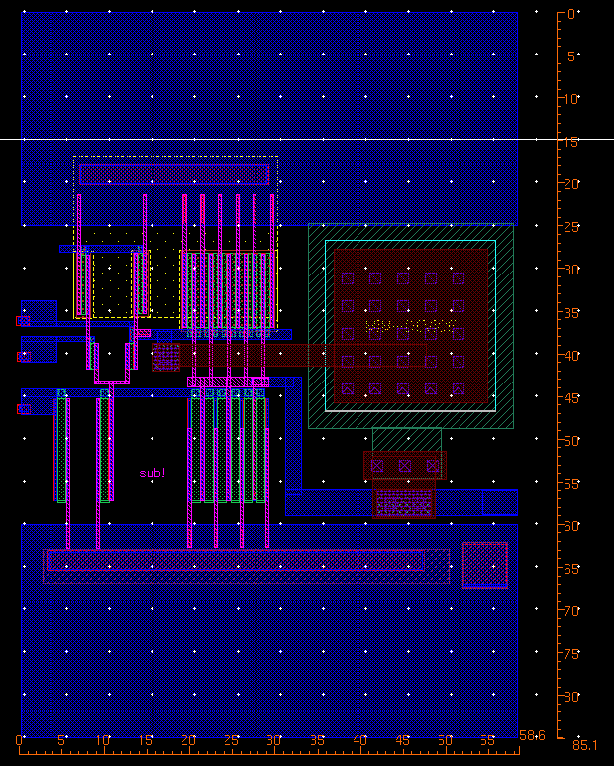
Fig. 14: Layout of OTA
  - Comparator
The layout of comparator is seen in Fig. 15.
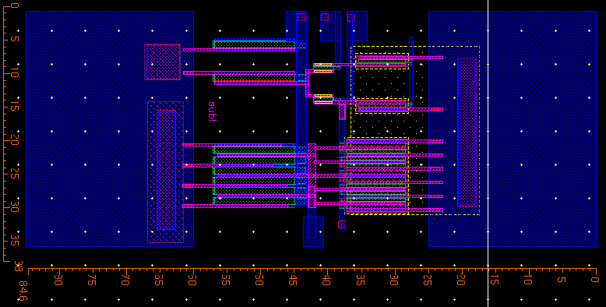
Fig. 15: Layout of comparator

  - Triangle wave generator
The layout of triangle wave generator is seen in Fig. 16.
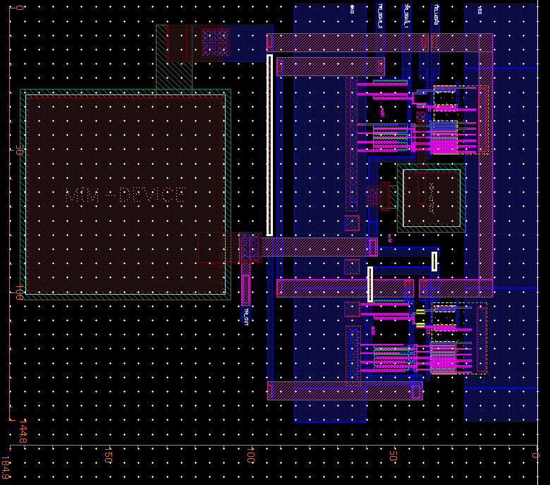
Fig. 16: Layout of triangle wave generator

  - Non-overlap generator
The layout of non-overlap generator is seen in Fig. 17. The layout area is mostly dominated by the MIM capacitors that provide the required delay. The relatively tiny digital gates are all located in the middle.

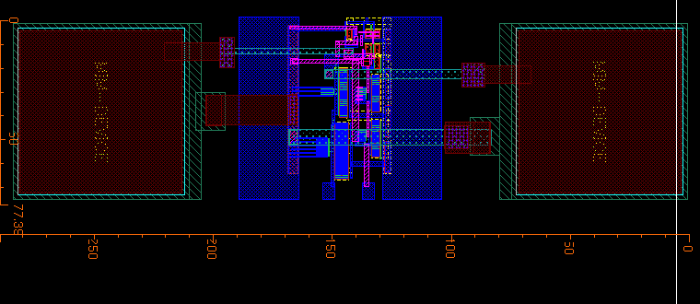
Fig. 17: Layout of non-overlap generator

  - Bias circuit
The layout of bias circuit is seen in Fig. 18.
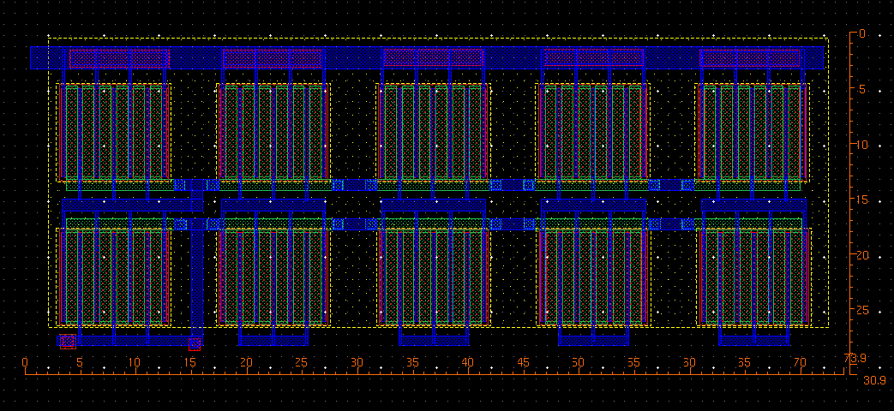
Fig. 18: Layout of bias circuit

  - Output driver
The layout of output driver is seen in Fig. 19. Starting from the left, the layout consists of the VSS bus, the NMOS pull-down, the output bus, the PMOS pull-up and the VDD bus. Metal layers are strapped together through the use of via arrays so as to minimize the wiring resistance and to increase the current-carrying capacity of the bus.

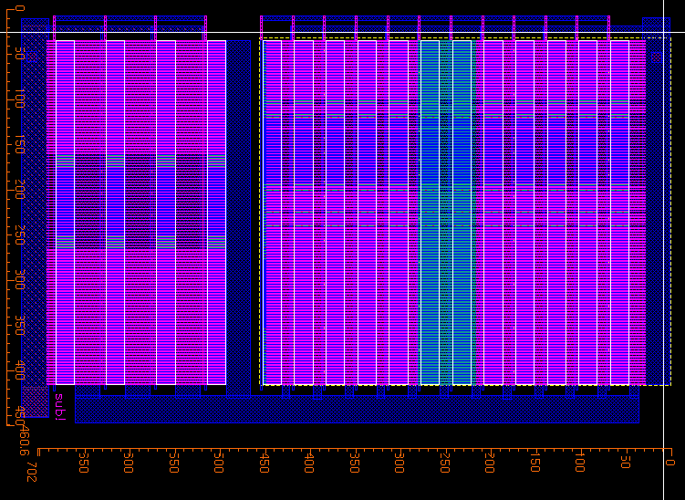
Fig. 19: Layout of output driver
- PCB Design
The schematic of the PCB that we designed to test the class-D amplifier is shown in figure 20. The board has an input option of two audio sources: direct input from a 3.5mm jack or audio received from an FM radio. An integrated switch on the board gives the user to choose one of the two. An Arduino board is connected in the bottom of the board and serves two purposes: I2C protocol to control the radio chip (SI4703) and to provide steady 5V and 3.3V. The control of the radio is done through the two push buttons and a potentiometer. The push buttons are for channel seeking up and down and the potentiometer adjust the volume of the radio signal. An LCD screen is included to present the current channel and the volume level. An antenna for the radio receiver can be attached either by using a telescopic antenna at the A1 via, or by using the shielding of a 3.5mm audio wire connected to J3.
The class-D amplifier is powered with two separate voltage: 1.8V and 0.9V, which are provided through separate voltage regulators. Our chip consist of several internal testing options such as measuring the internal triangular wave and the PWM signal, as well as passive (resistor/capacitor) and active (nmos/pmos) devices to confirm the simulated results. The access to those measuring pins is done by apply 1.8V to the appropriate pins (see chip pinout). By default, all the testing pins are connected to ground via two pin jumpers, and so can be easily disconnected to perform measurements. The board also includes a debugging area with a line of ground and 1.8V. Lastly, a low pass filter is designed to reconstruct an audio signal from the PWM.
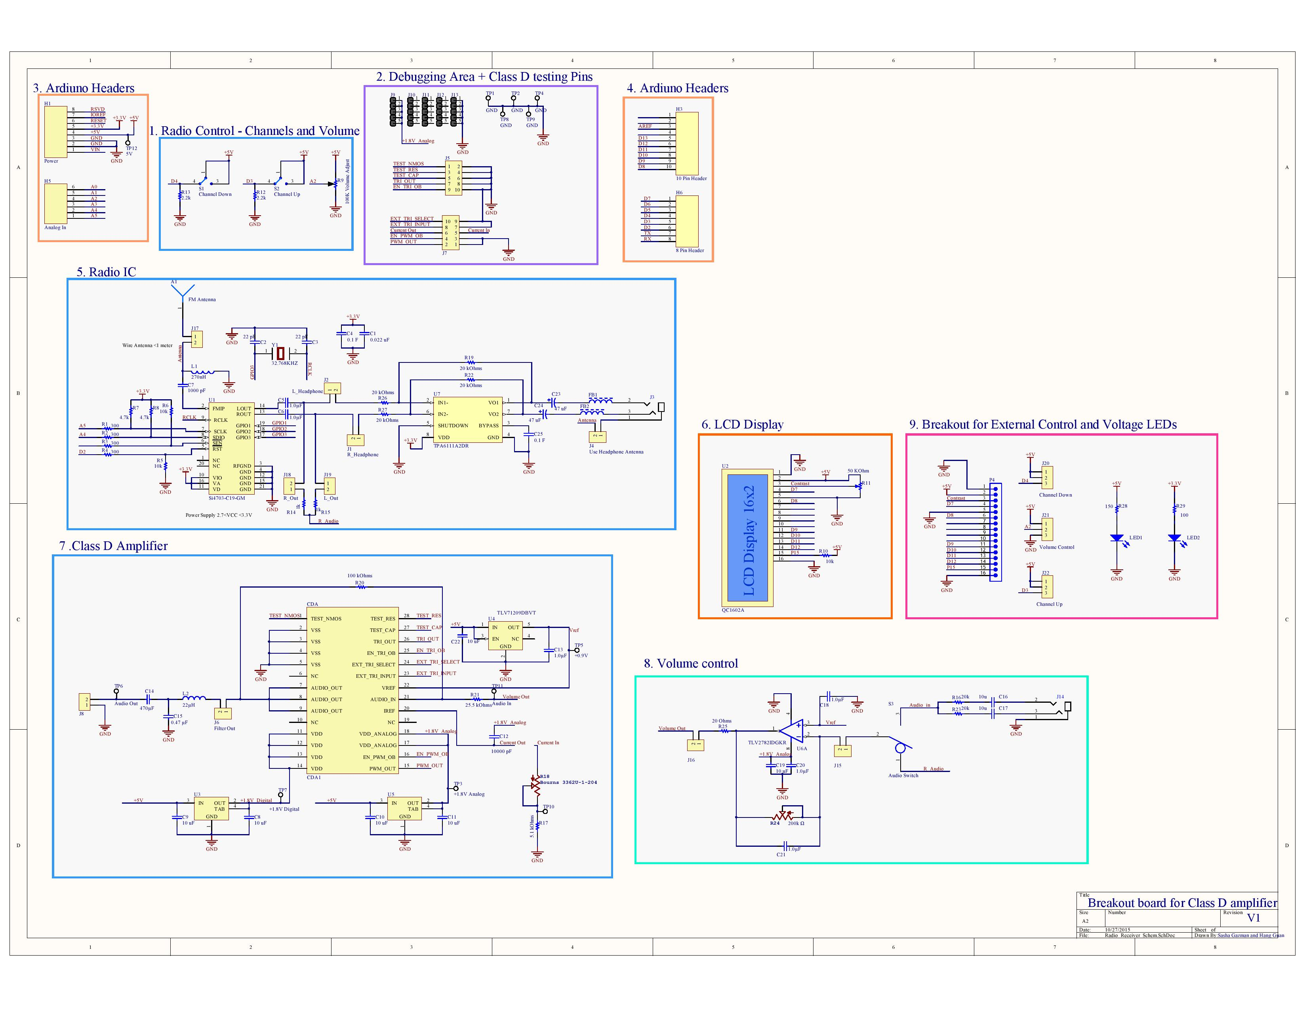

Fig. 20: PCB schematics
The physical layout of the board is shown in figure 21. This is a two layer board with a total area of 6" x 6", with the additional Arduino Uno board attached in the bottom layer. Modular ability was taken into consideration in the design - most of the blocks in the board are independent of each other. This was taken into account mainly for ease on debugging; it is also possible to see the large number of the testing points and discontinuity jumpers. Taking the advantage of placing components on both sides of the board, we could significantly decrease the size of the board. The latest release of the project can be found and downloaded from the CircuitMaker community under the Columbia _VLSI_AH653 tag.
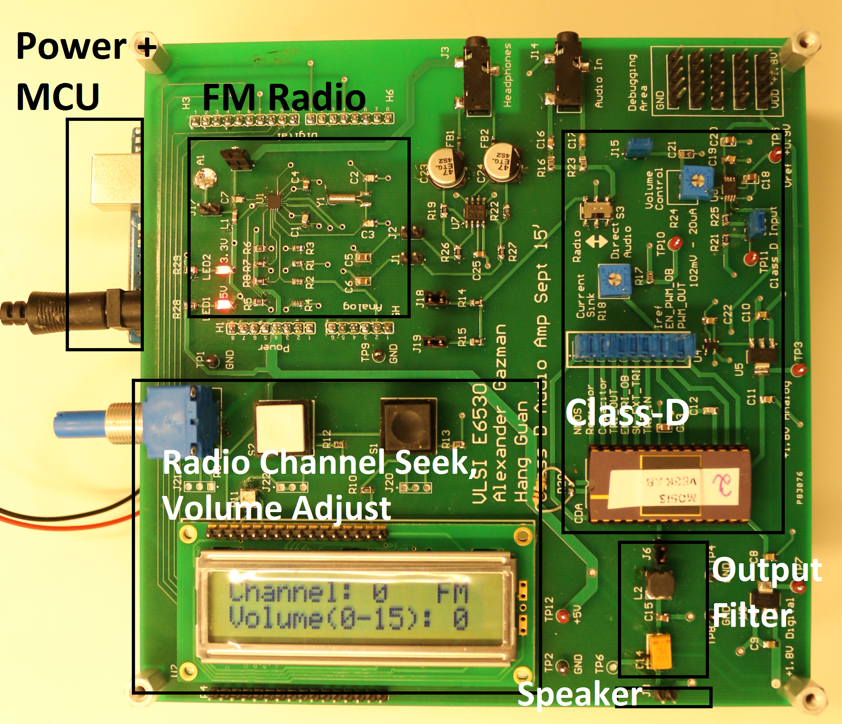

Fig. 21: Assembled PCB

- Testing
  - Corner analysis
Transistor performance and, as a result, system performance can be significantly affected by variations during the manufacturing process. Therefore, it is necessary to know if the devices on the chip being tested are typical, slow or fast. One way to determine this is to measure the I-V curves for transistors of known sizes on the chip. On our chip, we placed a test NFET on one of the control pins and used this and a PFET being used as a bias transistor to obtain the required I-V curves. By comparing our measurements with simulations, we determined that the chip being tested belonged to the SS (slow-slow) process corner.

  - Measured waveform
Figure 20 shows the single-tone test results. The yellow curve is the input sine wave with a DC biasing voltage of 0.9V. The blue curve is the output sine wave, with an amplitude gain of 3.2.

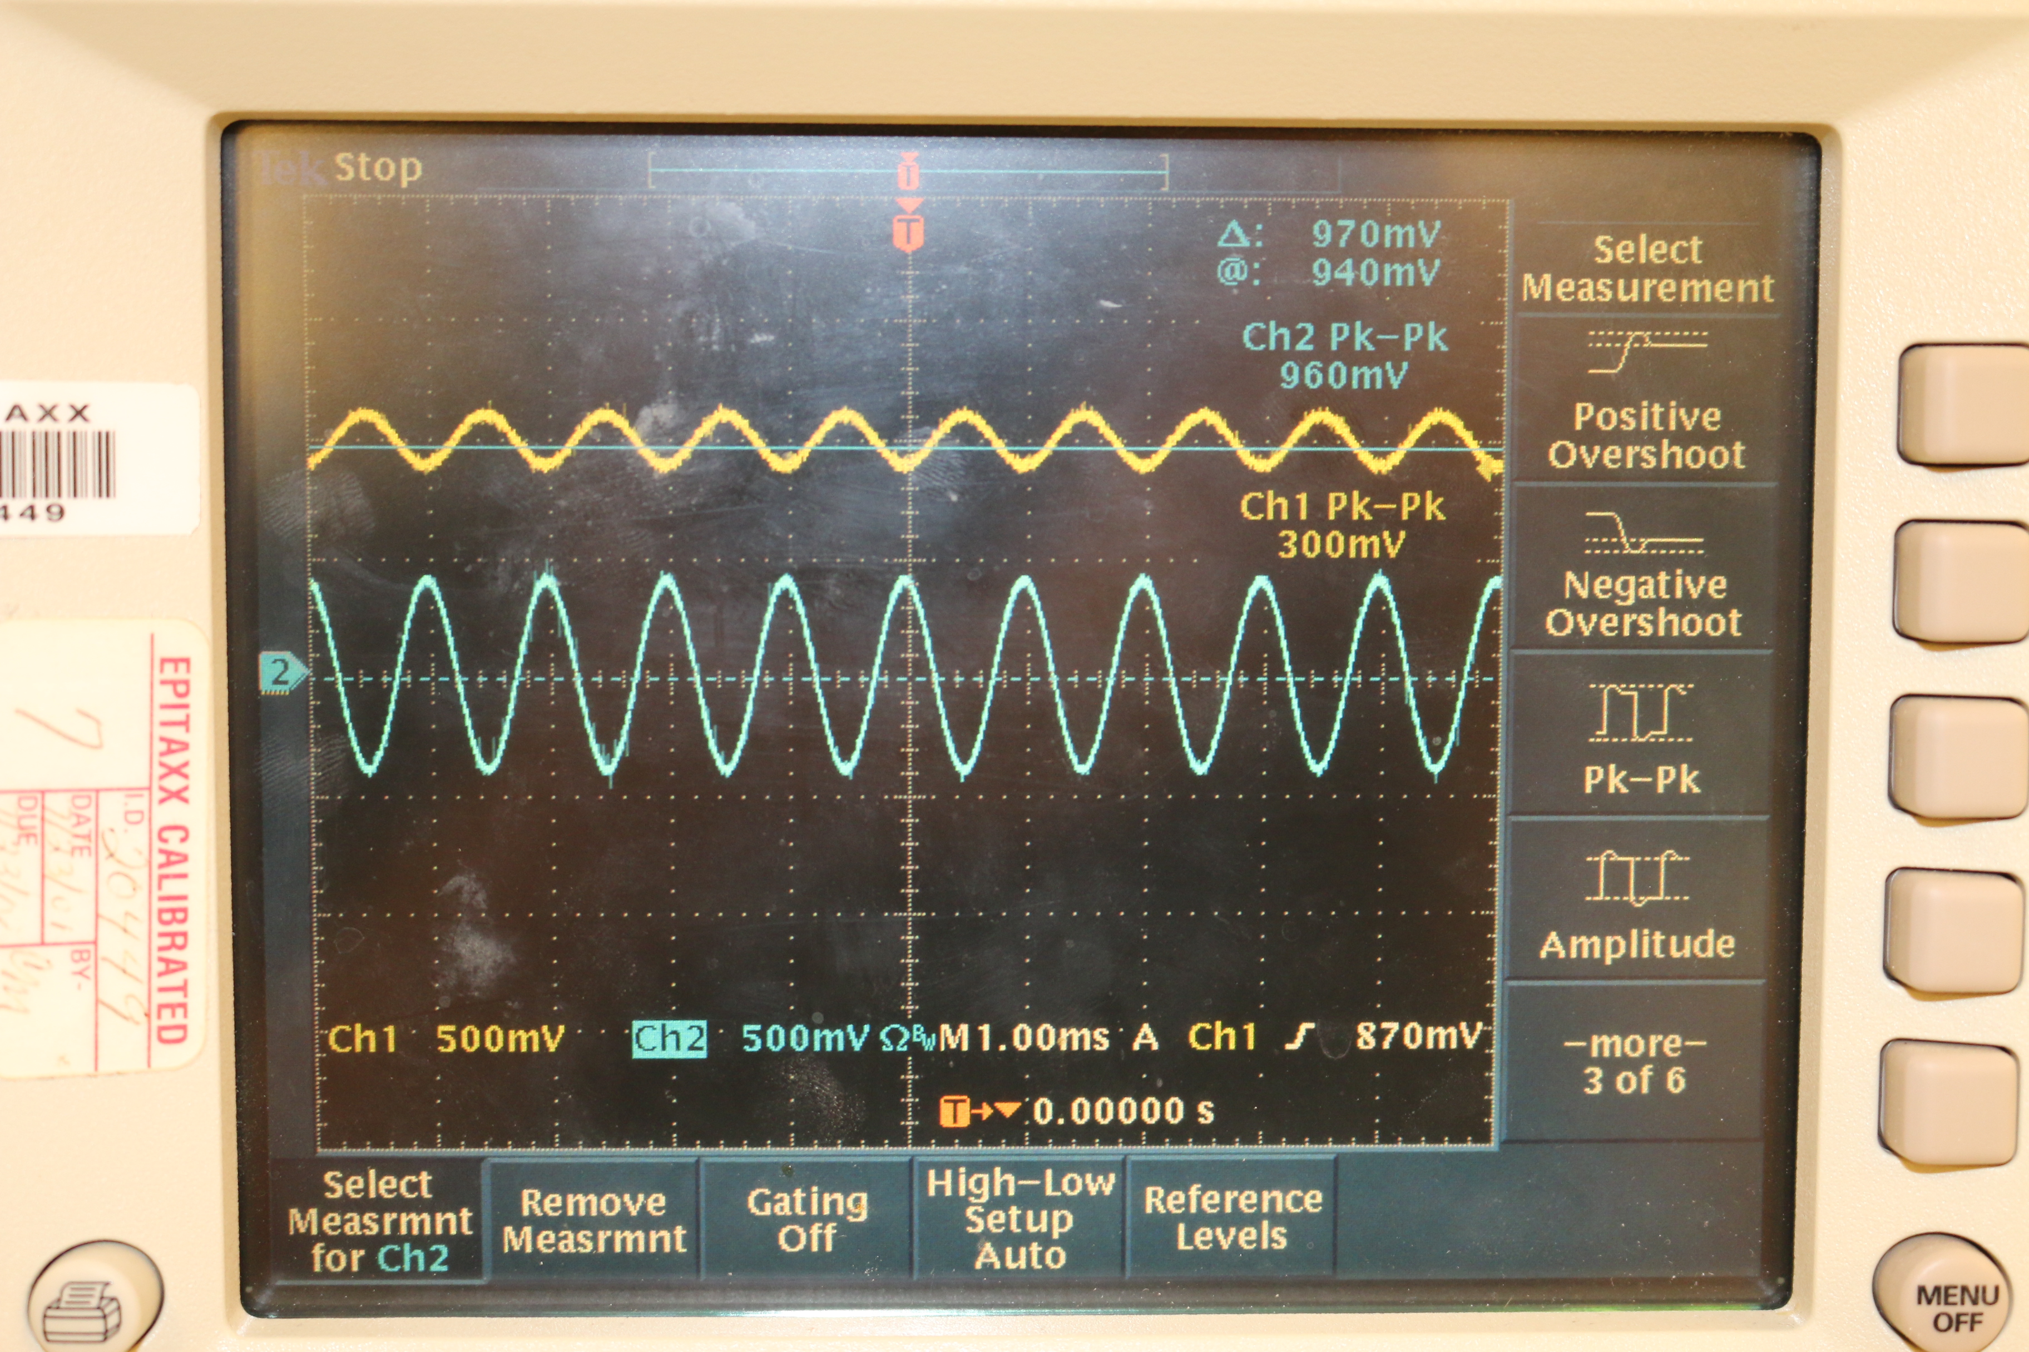
Fig. 20: Photo of measured input/output sinusoidal waveforms

The triangle wave generator on the chip was designed to produce a triangle wave with a frequency of approximately 500kHz and a peak-to-peak amplitude of 0.6 V. The option to supply an external triangle wave was also incorporated into the chip. Figure 21 shows a plot of the triangle wave generated on the chip as measured using an oscilloscope.

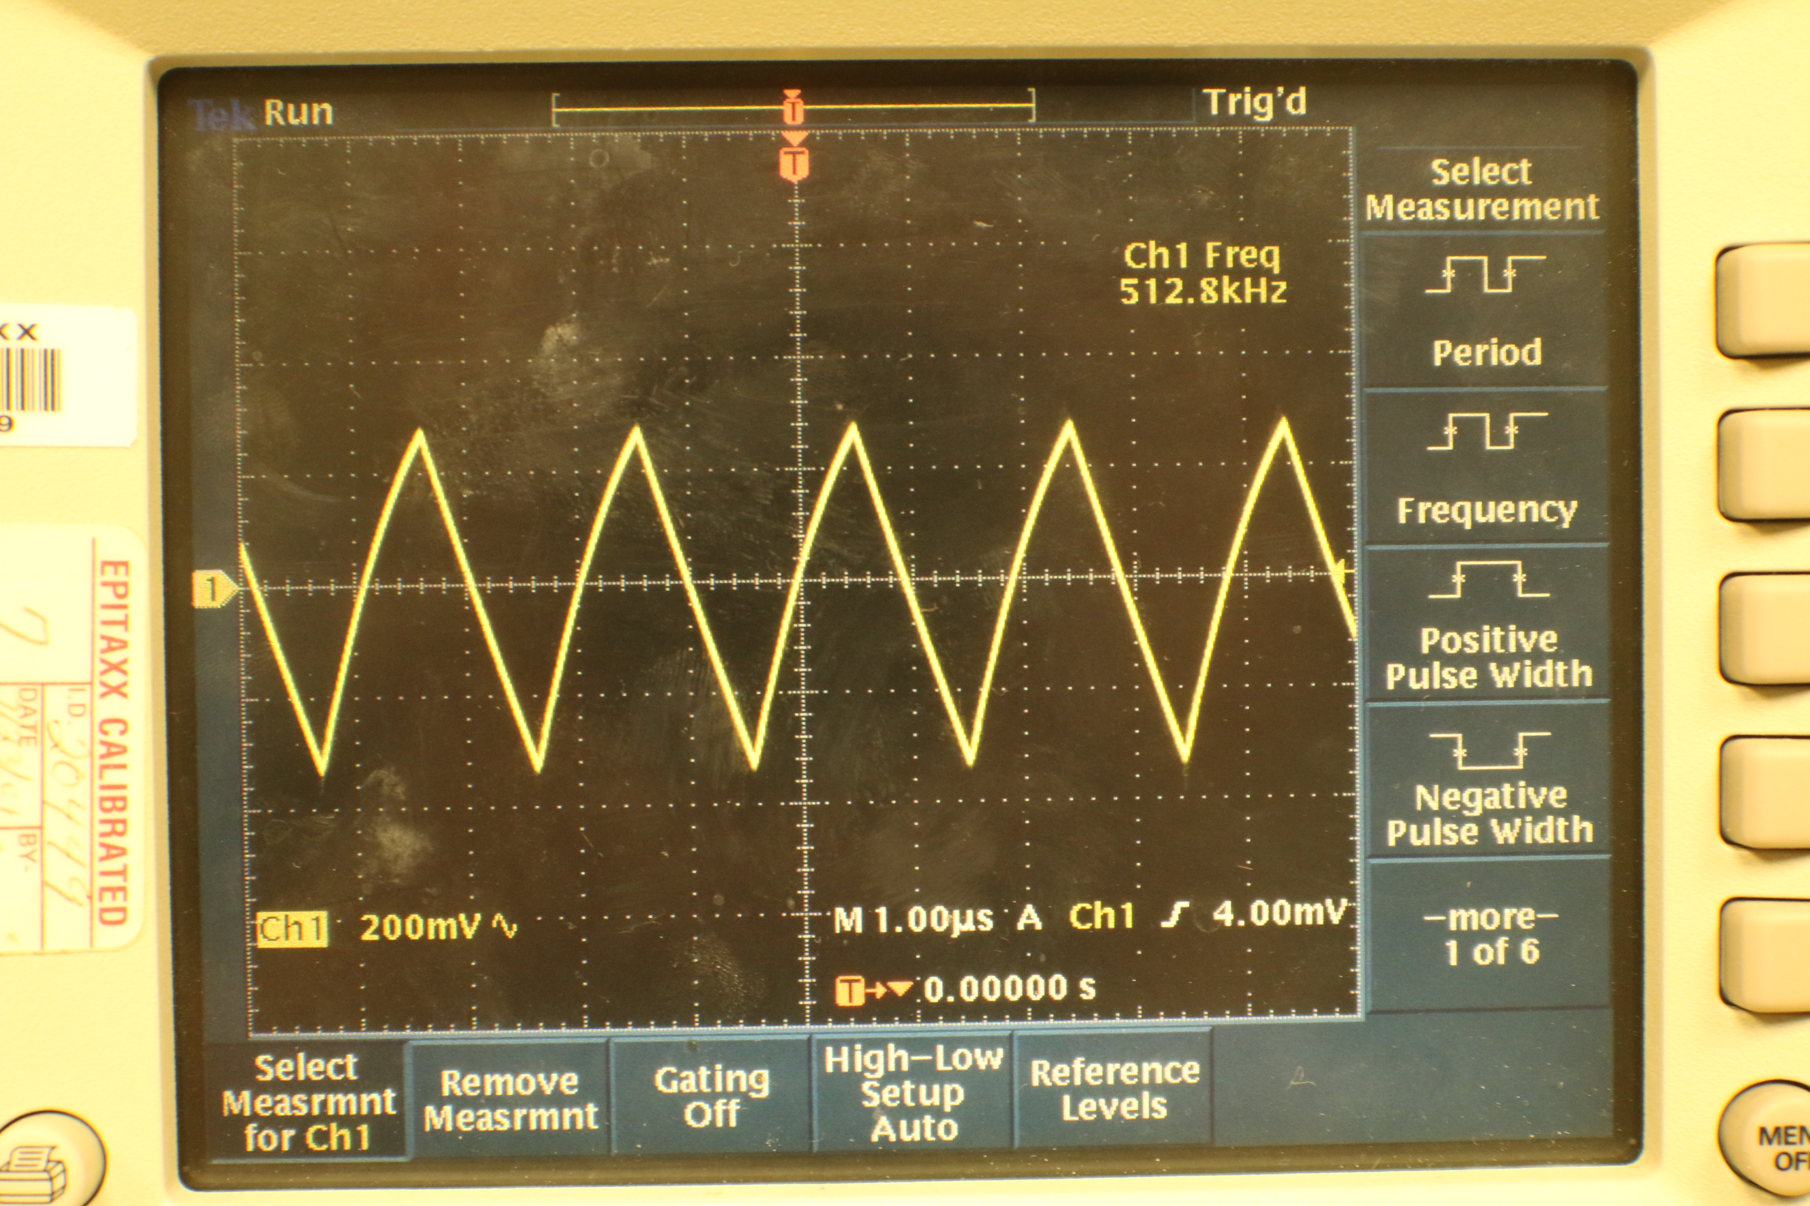
Fig. 21: Photo of measured internal triangle wave

Figure 22 shows the measured voltage gain with respect to the input frequency. The amplifier has a flat gain ranging from 200 KHz to 20 KHz, which covers almost all the human hearing range (20 Hz to 20 KHz).

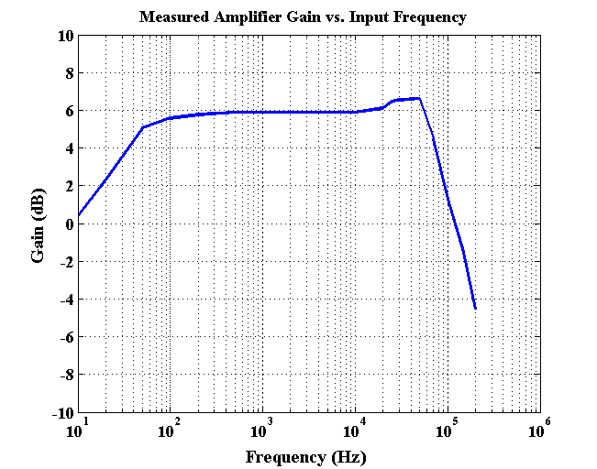
Figure 22: Photo of measured Gain vs. Frequency

- Conclusions
This project involved the design of a half-bridge class-D amplifier involving the full flow from deciding the system specifications to finally testing the IC on a custom-designed PCB. The important parameters for the chip can be seen in the table below

Parameter | Value
Analog Supply Voltage | 1.8 V
Digital Supply Voltage | 1.8 V
Voltage Gain | 4
PWM Frequency | 500 KHz
Peak output power for 8 ohm load | 50 mW

- Reference
[1] Jr. Leach, [Online]http://electro.uv.es/asignaturas/ea2/archivos/ClassD2.pdf.
[2] D. Cartasegna, P. Malcovati, L. Crespi, K. Lee and A. Baschirotto, "Design of high-order class-D audio amplifiers" in IC Design Technology(ICICDT), 2013 International Conference on, pp. 151-154, May 2013.
[3] Chierchie, F. and Paolini, E.E. "Analytical and numerical analysis of dead-time distortion in power inverters", in Argentine School of Micro-Nanoelectronisc Technology and Applications (EAMTA), 2010, pp. 6-11, Oct 2010.
[4] E. Gaalaas, "Class-D audio amplifiers: what, why, and how," Analog Dialogue, vol. 40, June 2003.
[5] S. Samala, V. Mishra, and K. C. Chakravarthi, "45 nm CMOS 8 class-D audio driver with 79% efficiency and 100 dB SNR," in IEEE ISSCC Dig. Tech. Papers, Feb. 2010, pp. 86-87.
[6] M. Berkhout, "An integrated 200-W class-D audio amplifier," IEEE J. Solid-State Circuits, vol. 38, no. 7, pp. 1198-1206, Jul. 2003.

