EE6350: Class-D Audio Amplifier Datasheet
Hang Guan (hg2388) and Alexander Gazman (ag3529)
- Features
- 1.8 V Operating voltage
- Efficiency > 80%
- 80 mA (rms) output stage drive strength
- Output power of 50 mW
- Short-circuit protection
- ESD protection

- Applications
- Portable audio devices
- PC audio systems

- General Description
The amplifier is a single-channel, efficient, class-D audio power amplifier for driving stereo speakers in a half-bridge configuration. It is designed to drive 8Ωspeaker with a gain of two. The chip can accept an analog signal as well as a pulse width modulated (PWM) signal from a microcontroller as an audio input.

- Block Diagram
Fig.1 shows the simplified block diagram of the class-D amplifier.

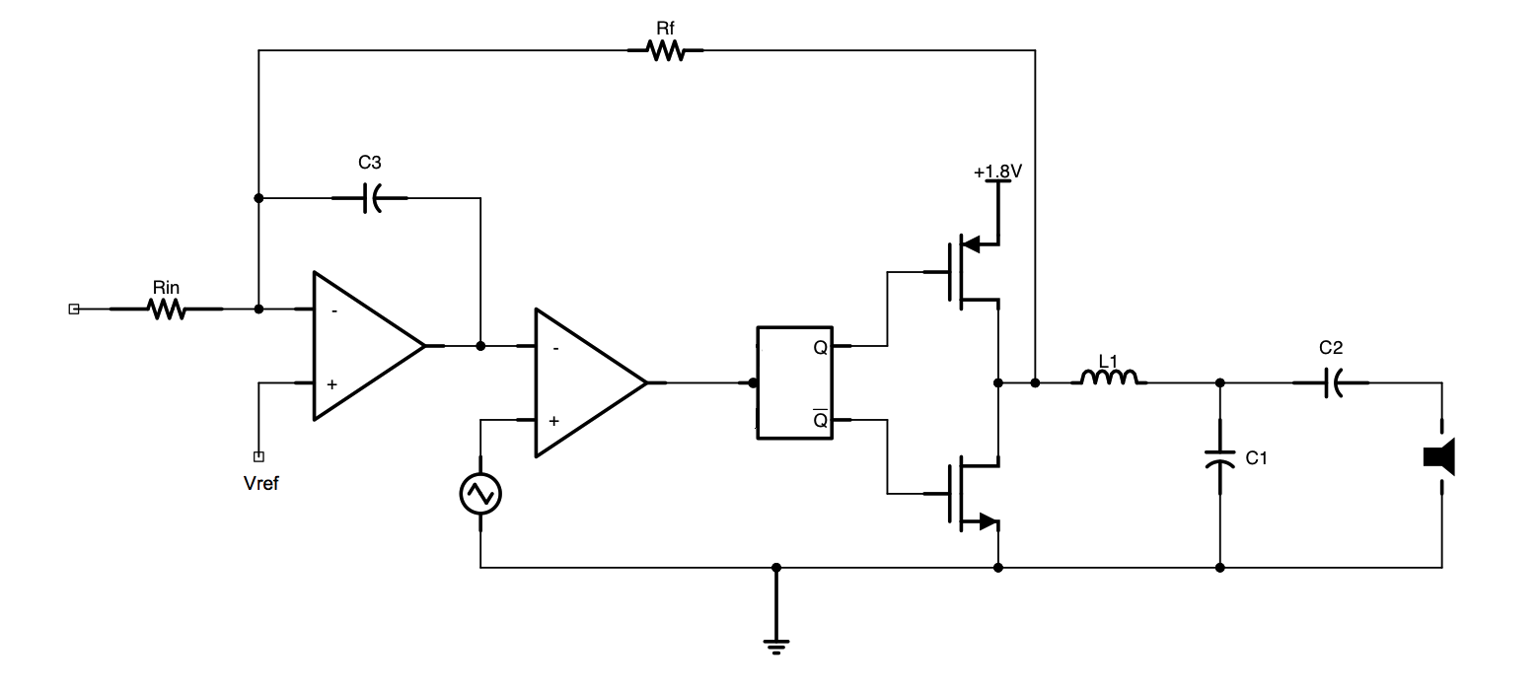
Fig. 1 Block diagram
The analog input signal flows into an integrator then compared with a triangular wave. The output of the comparator is PWM wave, and goes into the timing control block to create a dead time between the signal for the PMOS and NMOS of the output stage. Thus the time which both the NMOS and PMOS are conducted is limited and the power is reduced.

- Pin Configuration
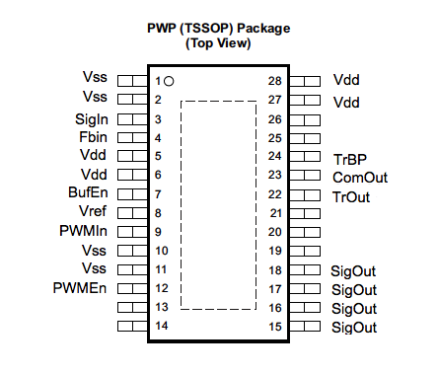
Fig. 2 Pin-out of the chip

PIN NAME | PIN NUMBER | I/O | DISCRIPTION
Vss | 1 | I | Connect to power ground
Vss | 2 | I | Connect to power ground
SigIn | 3 | I | Audio signal input
FbIn | 4 | I | Connect to the feedback resistor
Vdd | 5 | P | Connect to power supply
Vdd | 6 | P | Connect to power supply
BufEn | 7 | I | Enable signal for the entire chip
Vref | 8 | I | Reference voltage of the integrator
PWMIn | 9 | I | PWM audio signal input
Vss | 10 | P | Connect to power ground
Vss | 11 | P | Connect to power ground
PWMEn | 12 | I | Enable signal of PWM signal
SigOut | 15 | O | Amplified signal out
SigOut | 16 | O | Amplified signal out
SigOut | 17 | O | Amplified signal out
SigOut | 18 | O | Amplified signal out
TrOut | 22 | I/O | External triangle wave input/Internal Triangle wave test
ComOut | 23 | O | Comparator output
TrBP | 24 | I | Enable signal for triangle wave
Vdd | 27 | P | Connect to power supply
Vdd | 28 | P | Connect to power supply

- Application diagram
Figure 3 shows the application level connection for the Class D Amplifier chip. L and C2 formed a second-order low-pass filter and C3 is the decoupling capacitor. The recommended values are L=33 uH, C2= 220 nF, and C3= 470 uF.
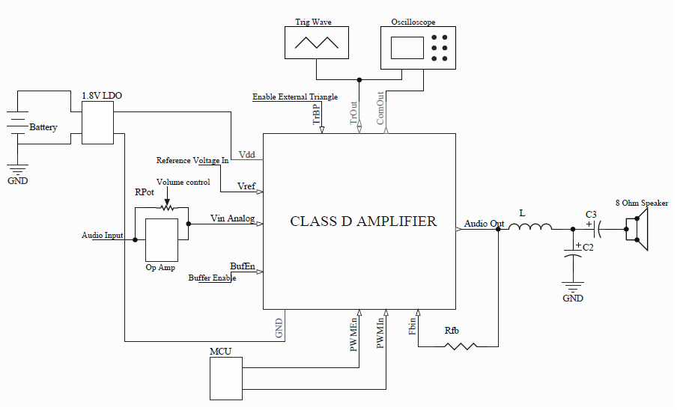
Fig. 3 Application diagram

